# SVN Configuration using GitHub

1. Select a physical location – to be used as project workspace   
   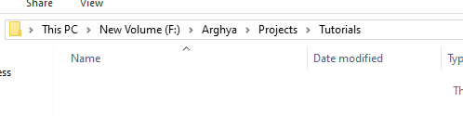
2. Write clicking over empty location select “**SVN Checkout…**”  
   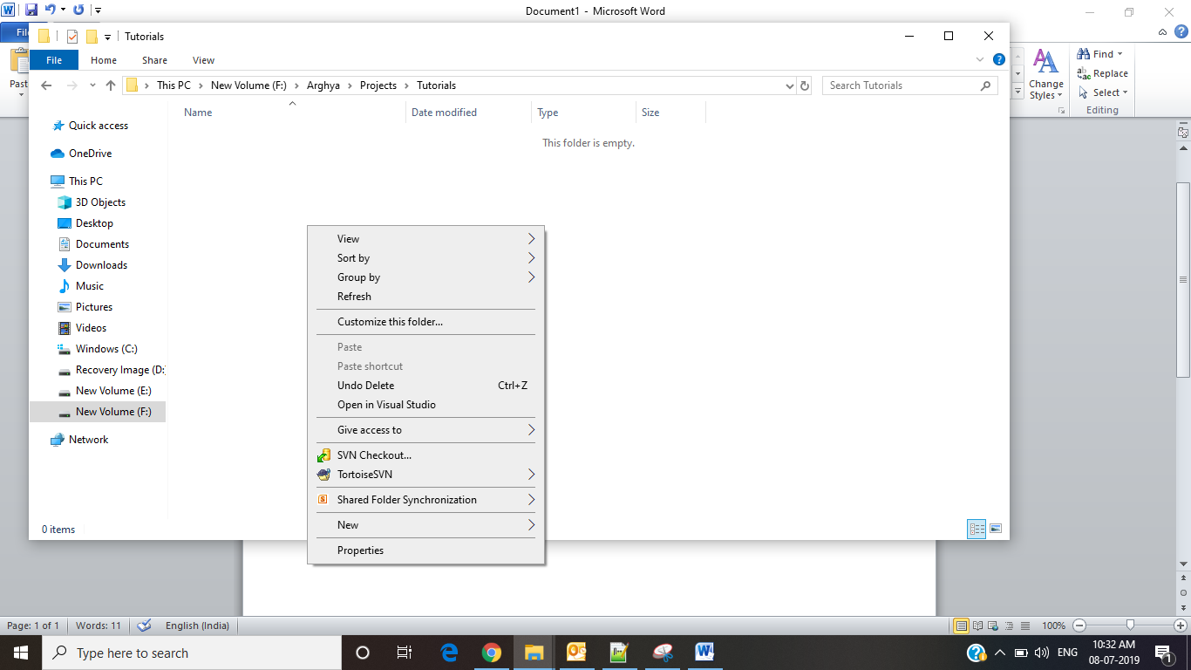
3. Add [**https://github.com/arghyabiswas/tutorials.git**](https://github.com/arghyabiswas/tutorials.git) under URL   
   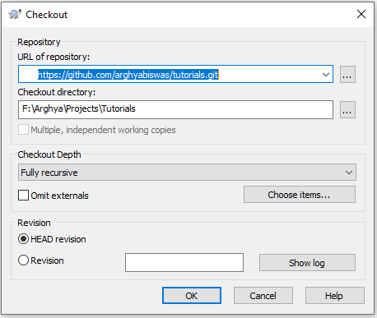
4. Successful Message like the following will be displayed  
   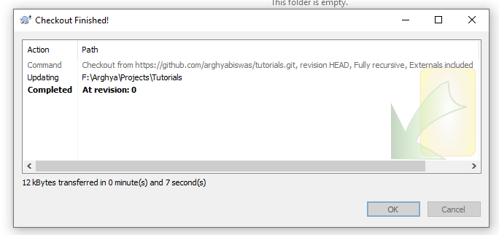
5. Click on “OK”
6. You will see two folder as follows use “trunk” for your use  
   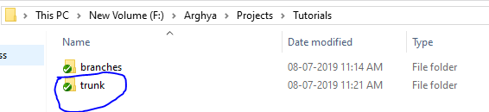

# Add Item to SVN

1. Select the file or folder to add under repository  
   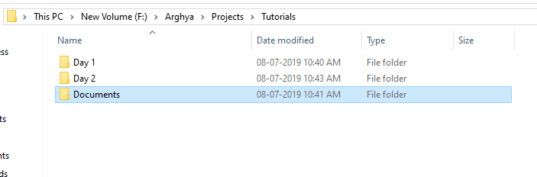
2. Write click over the folder/file select “TortoiseSVN” >> “Add”  
   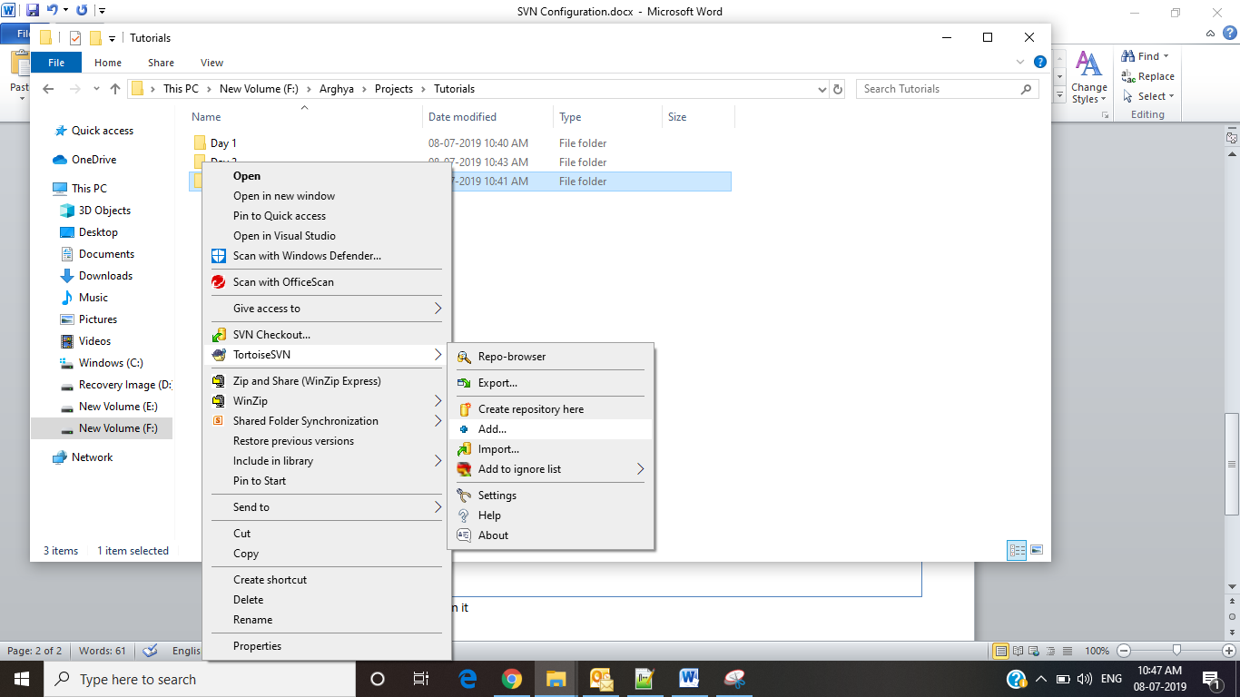
3. Select necessary file or folder to be added, unselect unnecessary files.   
   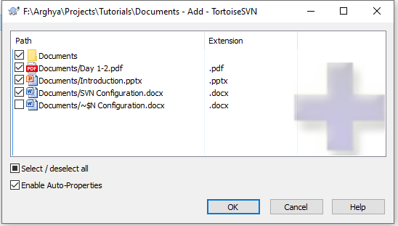  
   **Note: We should not add any EXE/DLL under repository,  
   Note: Unselect “bin”,”obj”,”.vs” folder while adding to repository**
4. Click “OK”
5. A confirmation message like the following will be displayed  
   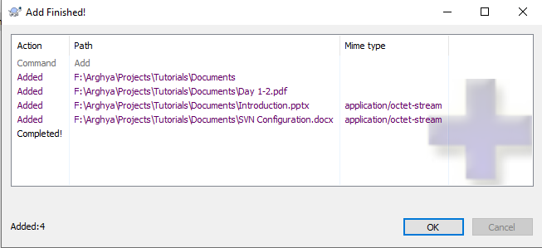
6. Once added the icon of folder will be changed   
   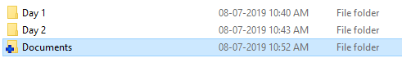  
   **Note: Adding dose not ensure the file is uploaded to server(GitHub)**
7. Write click over the file/folder select “**SVN Commit**…”  
   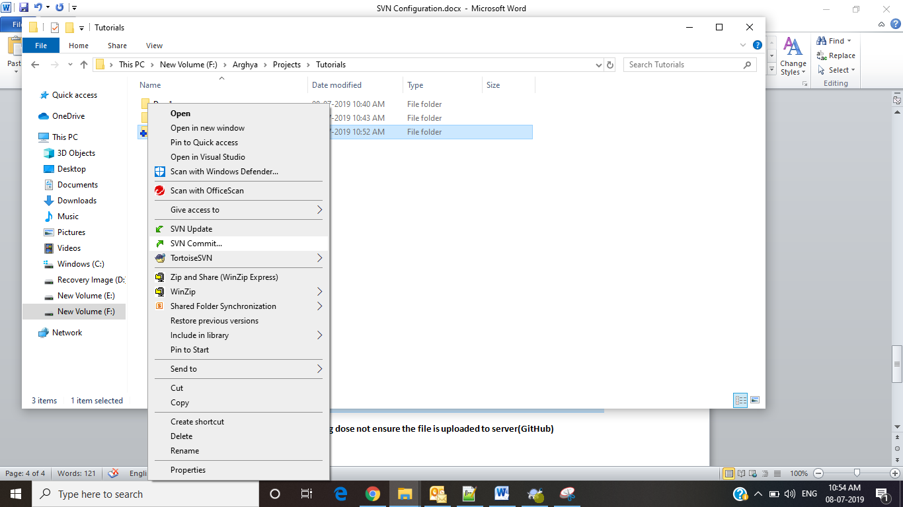
8. An window like the following will be open,   
   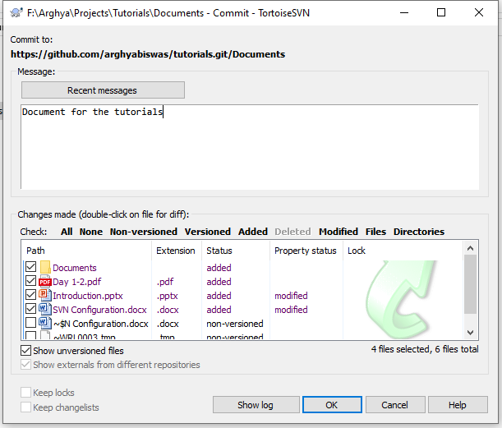
9. Write your comments under “Message box” and click on “OK”
10. This will prompt for authentication, If you don’t have **GitHub** account, create one for your use.  
    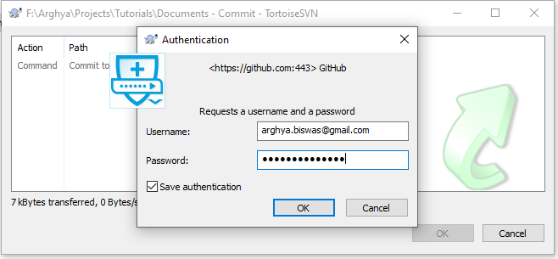
11. Success message as follows will be displayed  
    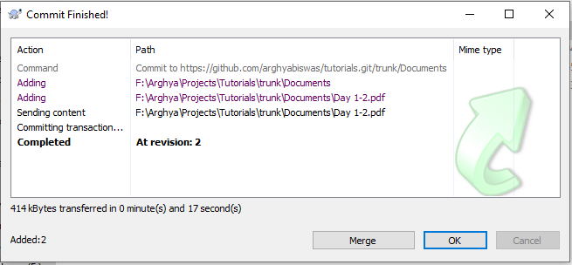
12. Icon of you repository will indicate accordingly as follows  
    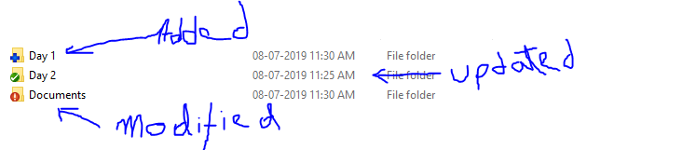

# Working with DEV Branch

**Creation of local repository for DEV branch**

1. Right click over the desired folder location, select “SVN Checkout…”  
   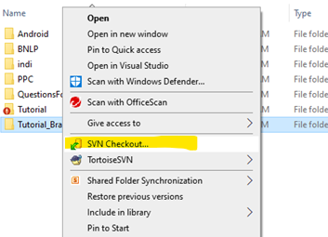
2. Select the URL of repository for your desired branch  
   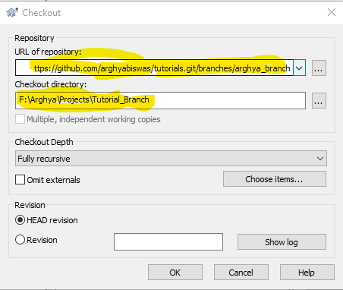
3. Select the desired branch to want to download.  
   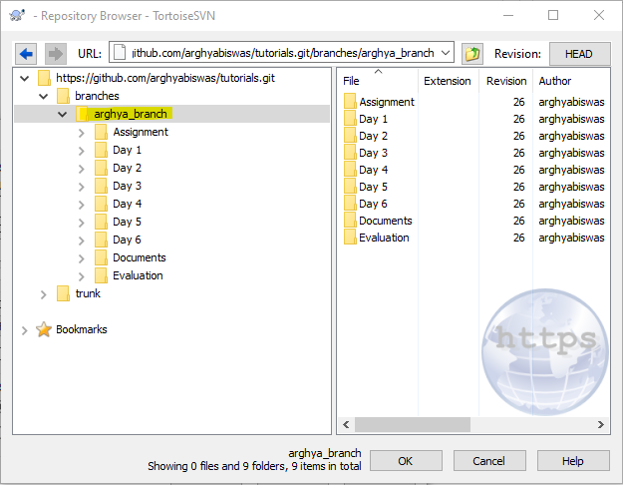
4. After successful completion message similar the following will be displayed  
   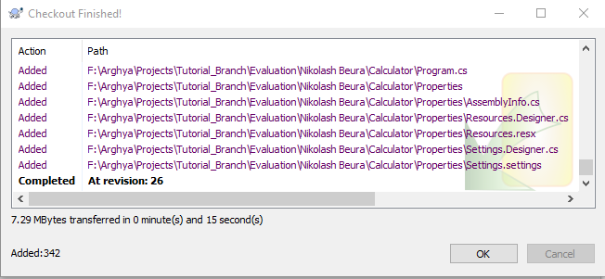

**Comparison between two branches**

*[Note: this process is comparing files under server after committing]*

1. Write click over your DEV branch, select Tortoise SVN >> Repo-browser  
   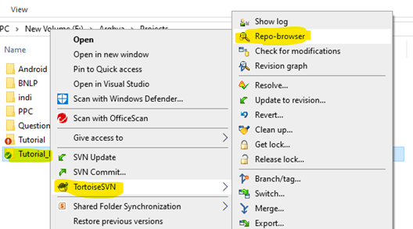
2. A window like the following will be open.  
   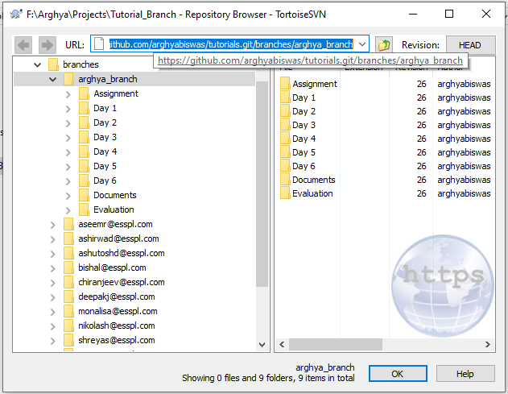
3. Suppose I want compare the **assignment** folder, in that case right click over the assignment folder of my DEV branch I have to select “Mark for comparison”  
   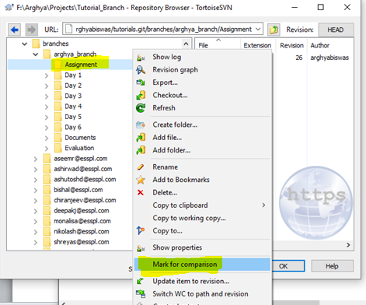
4. Expand the trunk( main branch)   
   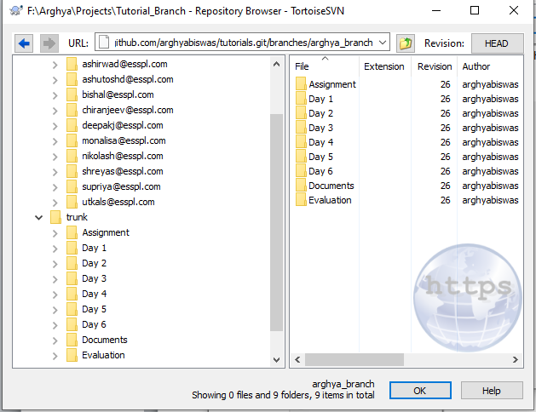
5. Right click over the assignment folder of main branch click “Compare URLs (content only)”  
   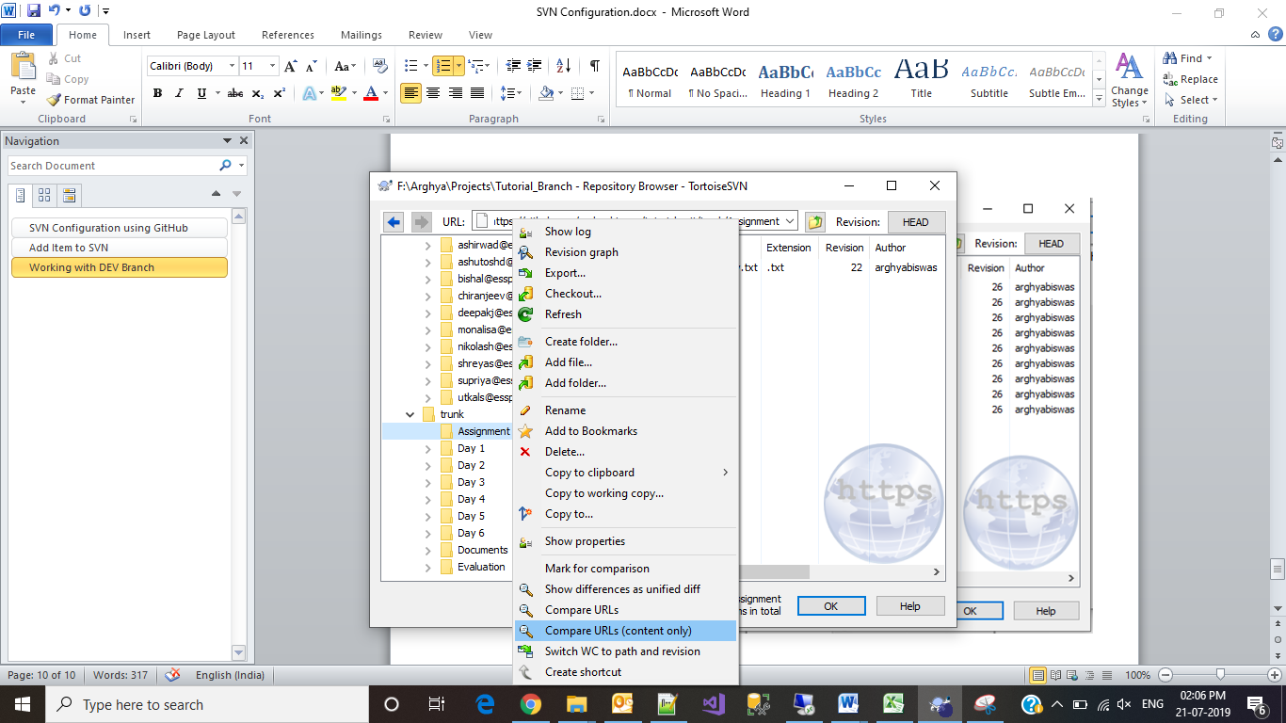
6. SVN will compare the content of each file and display the result as follows  
   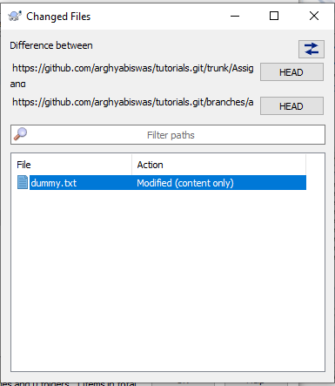
7. On double clicking over the file name we can see the differences in file.  
   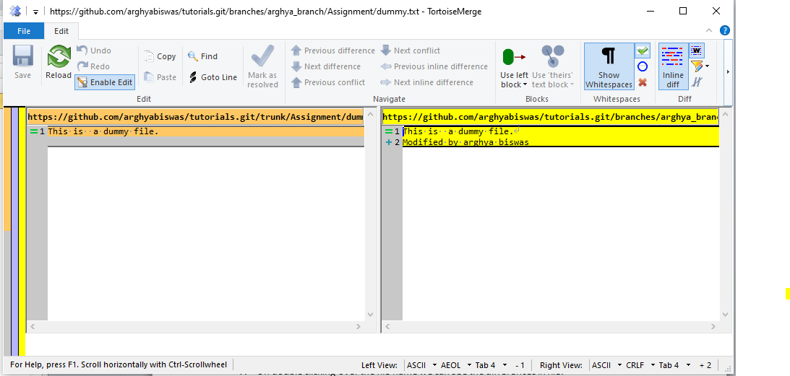

Compare local changes during development phase

1. If we want to compare file during development phase or before final commit we can do it by write clicking over the desired file or folder   
   Tortoise SVN >> Diff with previous version  
   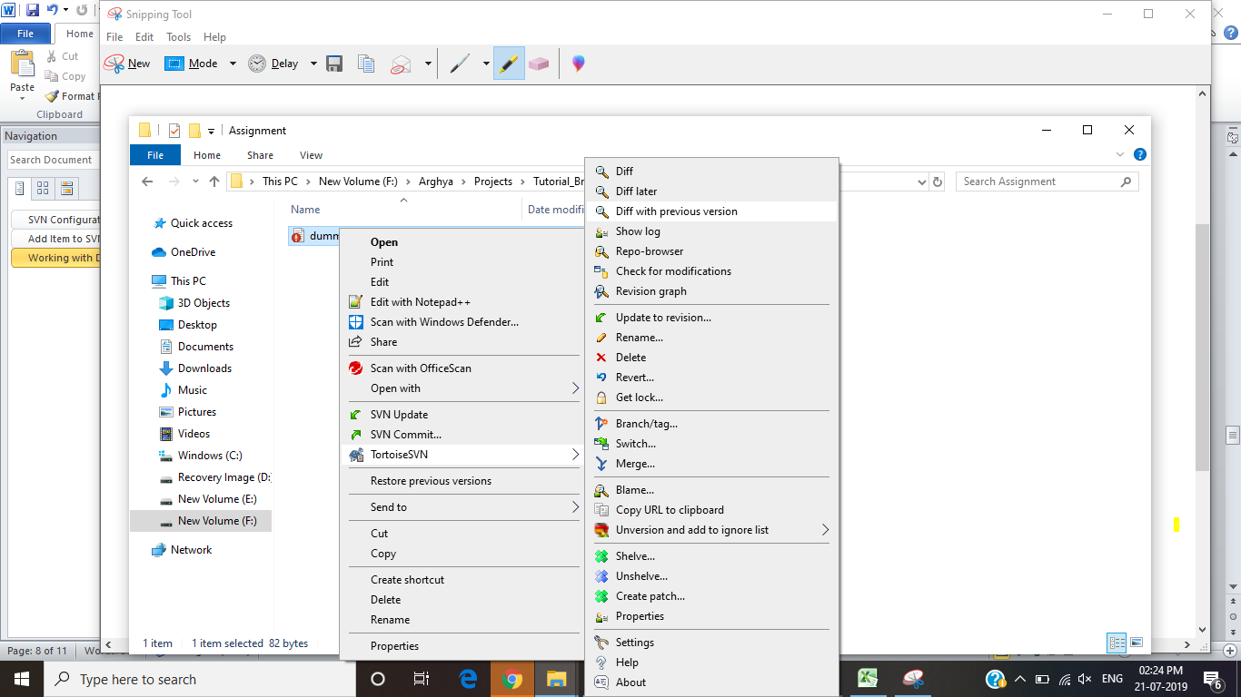
2. The difference will be visible as  
   